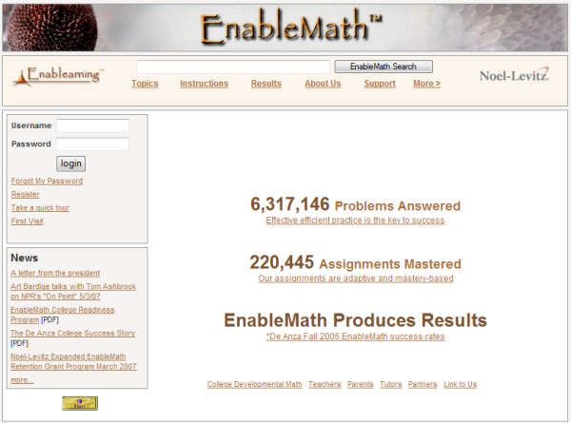
- Login on www.enablemath.com

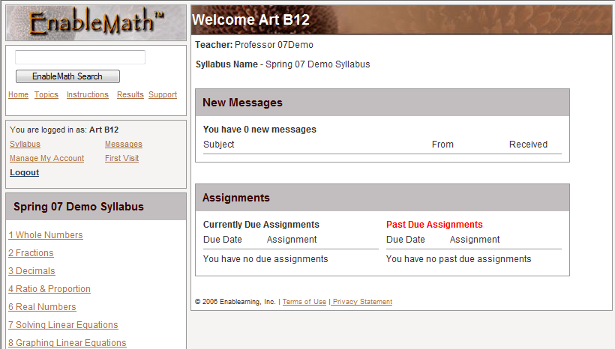
- Choose a Module or a “Due or Past Due Assignment”…

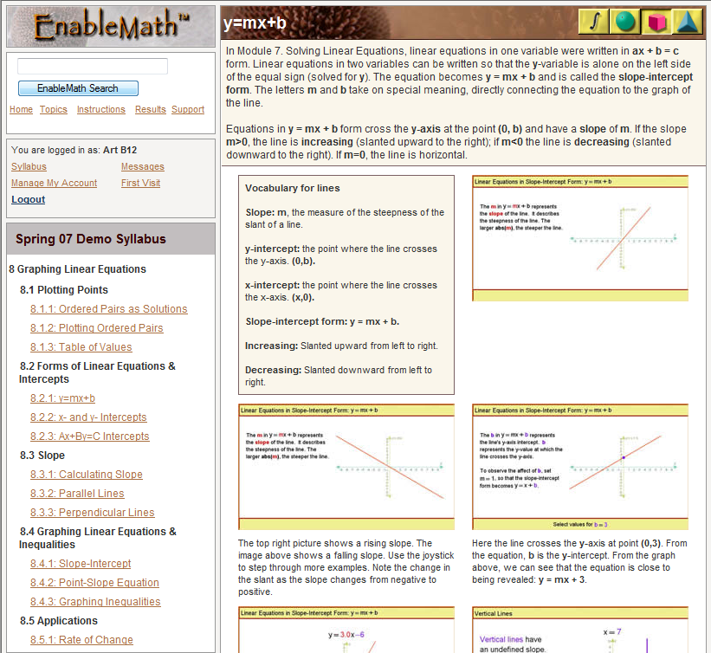
- …then a Lesson and an Assignment to bring up the Student Guide Example.

- Now you can:
- Read this page
- Click on an image to use EnableMath’s unique dynamic visual content.
- Click on the Green Circle to go directly to the problems
- Or click on the Blue Triangle to study the concept

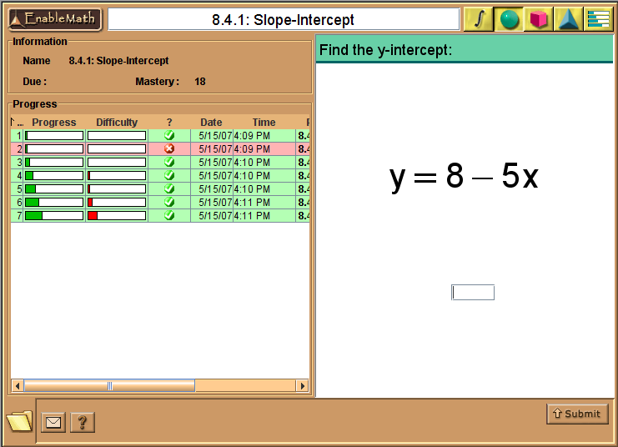
- EnableMath makes your practice efficient and effective by:
  - Giving you immediate feedback (light green is correct, pink is incorrect).
  - Tracking your Progress (Dark green bar).
  - Matching the problem’s difficulty with your progress.

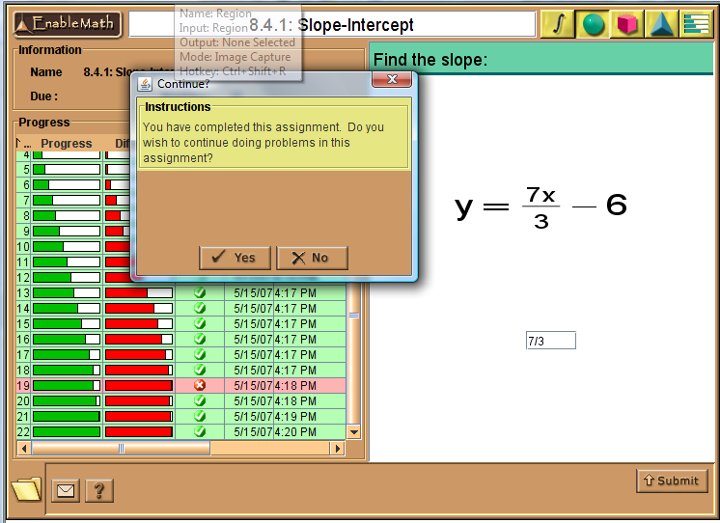
- You have completed an assignment when your Progress reaches Mastery (filled green bar).

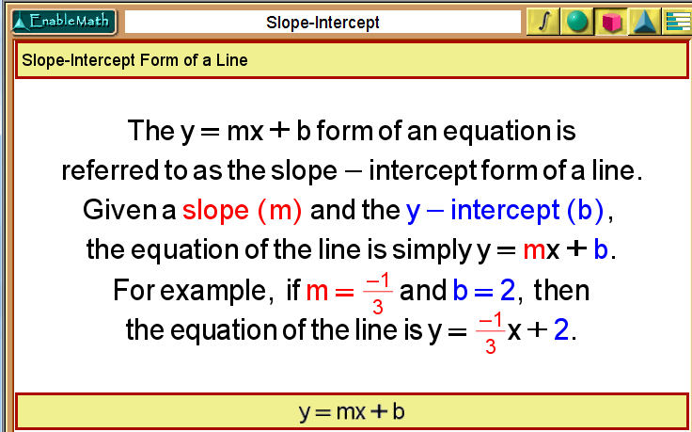
- If you need help click on the Red Square and Step Through the Example with the Joystick

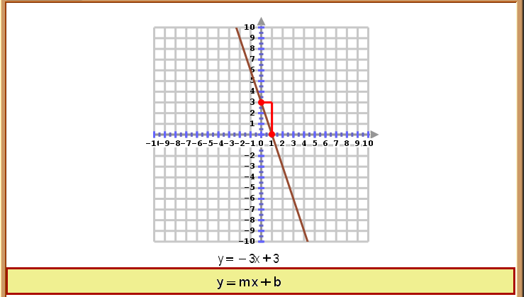

- Play with the Concept using the on-screen Joystick.
